

Turkish Electricity Market Report

July 2018



Written by:

Mohammed Saif Kazamel

# Executive Summary

The Turkish market was adopting the one buyer one seller model before the 1990s. It substantially changed since then. Currently, it is a quasi-liberal market on its way to becoming a fully competitive market. In addition to that, Turkey plans to increase its electricity generation from renewable sources and plans on having several nuclear power plants.

Currently, EÜAŞ is the public entity responsible for electricity generation. It generated 16.1% of the electricity consumed in 2017. TETAŞ has recently been merged with EÜAŞ, so now EÜAŞ signs the bilateral agreements and participates in the electricity wholesale market. TEİAŞ is the public entity responsible for transmission and it carries out all the electricity transmission and balancing operations. There are 21 private companies responsible for electricity distribution in 21 different zones. Also, 21 different private electricity retail companies are operating in the market. End customers whose consumption exceeds a certain threshold can choose their electricity supplier (retailer), while others can’t.

EPİAŞ is the electricity market operator and it is responsible for the financial settlement of the market operations. Market players participate in the market through the Market Management System.

Electricity generation has to balance consumption at all times. To ensure this, different markets are utilized within the current Turkish electricity wholesale market. In that market, electricity is traded through different channels:

* Bilateral Contracts
  + Currently, most of the electricity sales take place through this channel
  + Agreed parties don’t have to disclose the trading price to the market operator
* Day-Ahead Market
  + Trading happens one day before real delivery
  + Operates in a sealed bid manner
  + The price of this market is called Market Clearing Price
  + Has three types of orders: Hourly, Block, and Flexible
* Intraday Market
  + Gives the companies an opportunity to balance their load before real-time balancing
  + Trading happens until 90 minutes before physical delivery
  + Has two types of orders: Hourly and Block
* Balancing Power Market
  + Operated by TEİAŞ
  + The price of this market is called System Marginal Price
  + Only generation facilities can participate in this market
  + Facilities which can inject or offtake at least 10 MWh in 15 minutes or less are obliged to participate in this market

Contents

List of Abbreviations 1

1. Introduction 2

2. Electric Power Systems 2

3. Turkish Electricity Market 4

3.1. Entities in the Turkish electricity market and their roles 5

3.2. Overview of the current electricity market 6

3.3. EPİAŞ Electricity Market in Numbers (2017) 9

3.4. Wholesale Market 9

3.4.1. Bilateral Contracts (İA) 10

3.4.2. Day-Ahead Market (GÖP) 10

3.4.3. Intraday Market (GİP) 13

3.4.4. Balancing Power Market (DGP) 14

3.4.5. Financial Settlement 16

4. References 17

# List of Abbreviations

|  |  |  |
| --- | --- | --- |
| EPDK | T.C. Enerji Piyasası Düzenleme Kurumu | Energy Market Regulatory Authority |
| EPİAŞ | Enerji Piyasaları İşletme A.Ş. | Energy Exchange Istanbul |
| TEİAŞ | Türkiye Elektrik İletim A.Ş. | Turkish Electricity Transmission Company |
| EÜAŞ | Elektrik Üretim A.Ş. | Electricity Generation Company |
| TETAŞ | Türkiye Elektrik Ticaret ve Taahhüt A.Ş. | Turkish Electricity Trading and Contracting Company Inc. |
| GÖP | Gün Öncesi Piyasası | Day- Ahead Market |
| GİP | Gün İçi Piyasası | Intraday Market |
| DGP | Dengeleme Güç Piyasası | Balancing Power Market |
| YEKDEM | Yenilenebilir Enerji Kaynakları Destekleme Mekanizması | Renewable Energy Resources Support Mechanism |
| PYS | Piyasa Yönetim Sistemi | Market Management System |
| PTF | Piyasa Takas Fiyatı | Market Clearing Price |
| SMF | Sistem Marjinal Fiyatı | System Marginal Price |
| MYTM | Milli Yük Tevzi Merkezi | National Load Distribution Center |
| SBDT | Sıfır Bakiye Düzeltme Tutarı | Correction Amount for Zero Balance |

# Introduction

This report contains general information about the Turkish electricity market and its structure as well as some statistics from 2017 giving a general idea about it. It also contains more detailed information about the electricity wholesale market and how it operates.

I used the Turkish abbreviations in this report. You can check the Turkish names for the abbreviations from the List of Abbreviations section above.

You can check the references from the reference section below. They contain more information about the topics covered in this report.

# Electric Power Systems

Electricity is an integral part of our life nowadays and as time passes we get more and more dependent on it. Here we will briefly explore the system behind this energy powering most of our devices.

A modern electrical power system can be roughly divided into three parts. Namely: Generation, Transmission, and distribution. Electricity cannot be economically stored with the technological limitations of this age. Hence, it has to be consumed the moment it is generated.

Resources from which electricity is generated are broadly divided into renewable and non-renewable resources. All the generation facilities are connected to the same grid as shown in Figure 1. We generally have more control over the amount of electricity generated using the non-renewable resources. On the other hand, the renewable resource electricity generation amounts are largely related to weather, except for hydropower generation. Therefore, in the current systems, electricity generation using non-renewables has to be adjusted according to the amount of consumption and the renewable resource generation. In other words, the consumption and renewable generation are taken as exogenous variables, with minor exceptions.

The higher the voltage of electricity, the lower the amount of it lost during transmission. Therefore, the electricity is transmitted from the generation areas to the distribution areas in high voltage, then the voltage is gradually lowered during distribution until it reaches the consumers with the suitable voltage for their electricity needs.

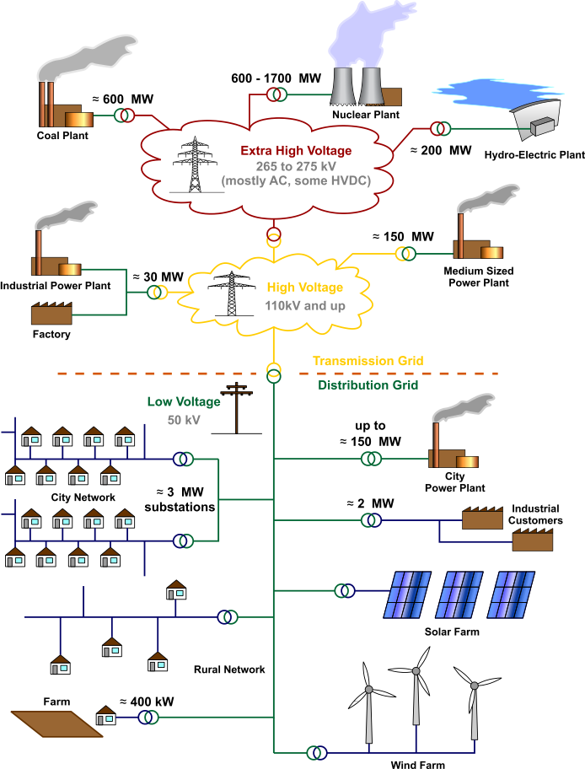

Figure 1: Overview of an electric power system Source: Wikimedia Commons

# Turkish Electricity Market

Here we briefly explain the development of the Turkish market and the entities that exist in it and the role of each entity and give an overview of the market, then we explain the energy trading markets and how they operate.

The electricity system in Turkey has gone through many changes on its way of transforming from the one buyer one seller model to the liberal competitive market model.   
Figure 2 below depicts the changes that happened to the Turkish Electricity Institution (TEK) over the years. The 21 distribution and retail companies are currently privatized. Each of these 21 companies is responsible for its distribution zone. Zones are shown in Figure 3 below.

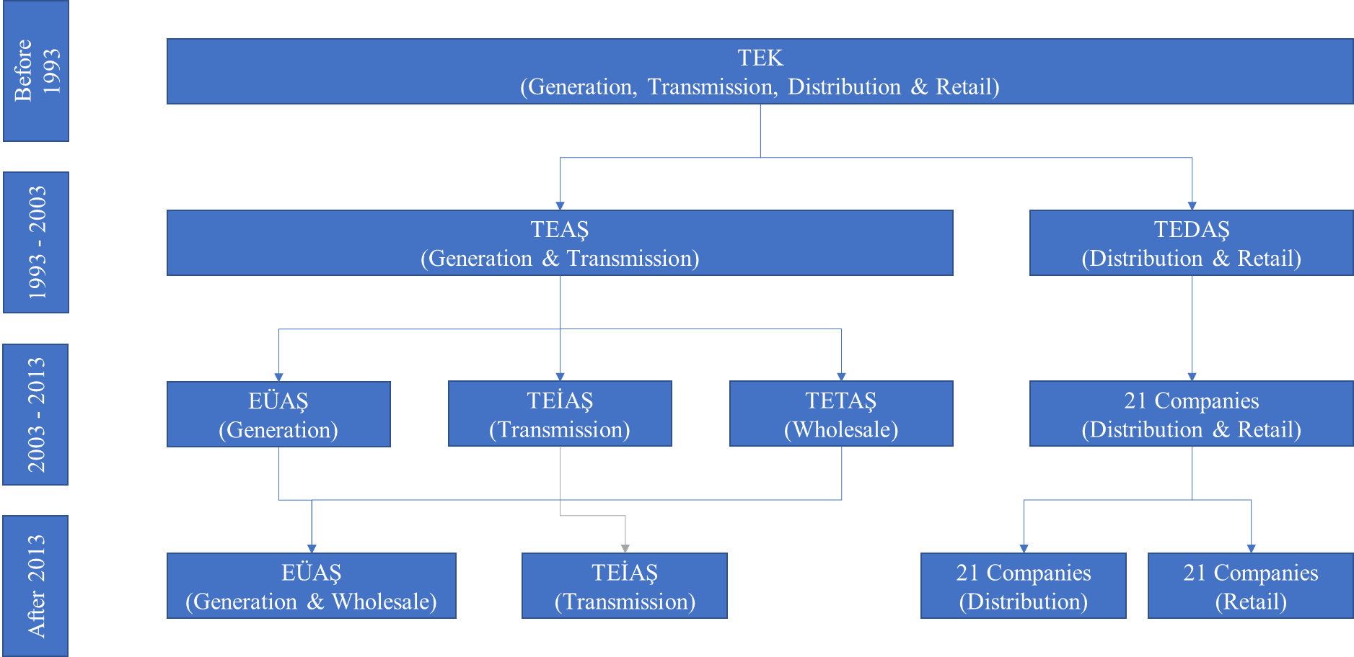  
Figure 2: Turkish electricity system structure evolution

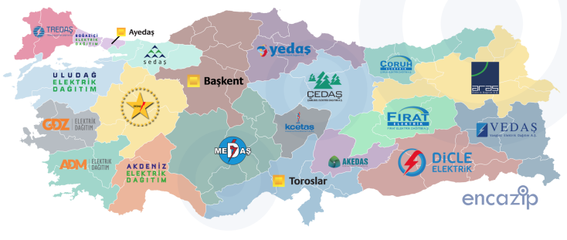Figure 3: Electricity distribution zones Source: encazip.com

## Entities in the Turkish electricity market and their roles

|  |  |
| --- | --- |
| Ministry of Energy | Creates and supports the strategic plans. |
| Energy Market Regulatory Authority (EPDK) | Regulates the energy market. |
| Turkish Electricity Transmission Corporation (TEİAŞ) | The System Operator and command center which is responsible for balancing. Electrical balancing and frequency regulation are done by TEİAŞ. All TEİAŞ activities are subject to financial settlement. |
| Energy Exchange Istanbul (EPİAŞ) | The command center responsible for the financial operation of the system. Financial balancing and settlement are done by EPİAŞ which is also the Market Operator. |
| Turkish Electricity Trading Company (TETAŞ) | A governmental company which is responsible for the bilateral contracts between generation plants and the retailers who provide electricity to the public. Its activities are regulated by the Law. It was restructured as a part of EÜAŞ as of July 2018. |
| Electricity Generation Company (EÜAŞ) | The state-owned generation company. Generated energy is sold in the electricity market or via bilateral contracts. |
| Electricity Distribution Company (EDAŞ) | The 21 electricity distribution companies that came about with the privatization of TEDAŞ. |
| Electricity Retail Company (EPSAŞ) | Electricity retailers who sell to the end customers. 21 one of them exist. Used to be part of distribution companies (EDAŞ) before they were unbundled by law. |
| End-customer | There are two types of end customers. Those who can choose their electricity supplier and those who can’t. A customer can choose his electricity supplier after reaching an electricity consumption rate determined by the regulatory authorities. This rate has been decreasing over the years and hence the number of customers who can choose their supplier increased. |

## Overview of the current electricity market

After moving away from the single buyer single seller model, the electricity generation, transmission, distribution, and retail are performed by many different entities. Generally speaking, Electricity generation is performed by EÜAŞ and other private generation companies. The generated electricity is sold to retailers through bilateral contracts or through the day-ahead or the intraday markets and the retailers, in turn, sell the electricity to the end users like houses or factories etc.

The physical transmission of electricity from generation areas to distribution areas is currently operated by TEİAŞ. Because the amounts of electricity traded in the aforementioned markets are not always the same as the actual consumption by end customers in real time, TEİAŞ balances the electricity generation and consumption using the generation companies’ offers in the balancing power market (These markets are explained in more detail in later sections). The market participants can also use instruments available in the derivative markets to hedge against risk. Figure 4 below summarizes the market structure.

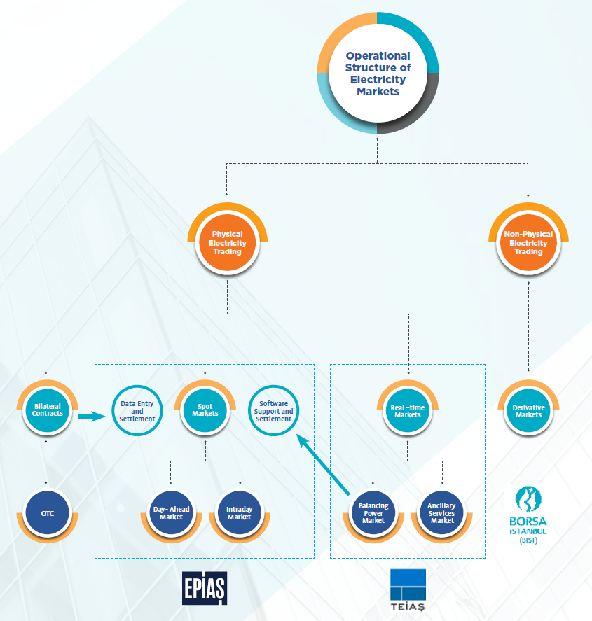

Figure 4: Market structure Source: EPİAŞ Annual Report 2017

Figure 5: The share of each market mechanism in the wholesale electricity market volume in 2017

We can see from Figure 5 that currently most electricity is sold through bilateral contracts in the wholesale market. As more features and improvements are added to the day-ahead and intraday markets, their share is expected to increase in the upcoming years.

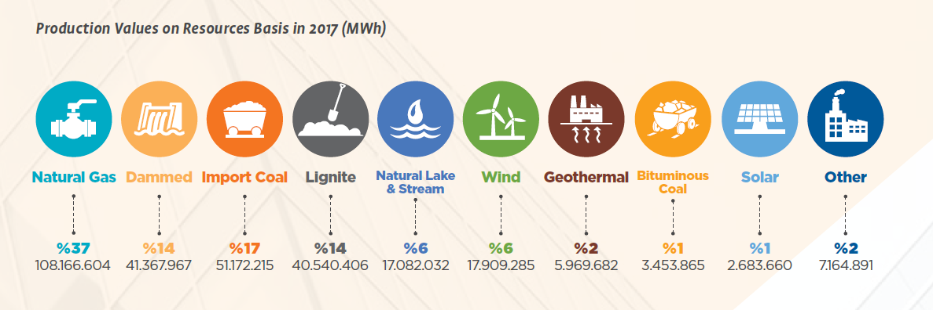

Figure 6: Electricity generated from each resource type in 2017 Source: EPİAŞ Annual Report 2017

In Figure 6 we see that 37% of the electricity is generated using natural gas followed by imported coal of which 17% is generated. Turkey has a plan that by 2023, 30% of electricity would be generated from renewable sources. There is currently no operational nuclear power plant in Turkey. However, to decrease its dependency on imported energy and secure its own energy supply, it is a key aim for the future. According to the CIA world factbook, Turkey is ranked the 20th among world countries in terms of electricity consumption.

## EPİAŞ Electricity Market in Numbers (2017)

*Source: EPİAŞ annual report 2017*

• Market Participants Registered with EPİAŞ **1058**

• Average Market Clearing Price (PTF) of **TRY 163.84/MWh**

• Day-Ahead Market (GÖP) Cleared Volume: **123.32 TWh**

• Block Sales Cleared Rate **38%**; Hourly Sales Cleared Rate **62%**

• Block Purchase Cleared Rate **4%**; Hourly Purchase Cleared Rate **96%**

• GÖP Trading Volume **TRY 41.47 Billion** (Sum of purchase-sale)

• Intraday Market (GİP) Cleared Volume **1.72 TWh**

• Intraday Trading Volume **TRY 576.7 million**

• Total Production **295.5 TWh**

• Total Consumption **294.9 TWh**

• Installed Capacity of the Power Plants Registered with EPİAŞ in Operation. **83.275 MW**

• Installed Capacity in Operation by Resource: Thermal **56.35%**, Hydraulic Resources **34.12%**, Wind **8.16%**, Geothermal **1.33%**, Solar **0.028%**

• Total Amount of Renewable Energy Resources (RER) **TRY 15.34 Billion**, Average Unit Cost of Renewable Energy Resources Support Mechanism (YEKDEM) for Unit Draw Amount for 2017 **TRY 34.04/MWh**

• Power of plants included in YEKDEM in operation: **18,934.58 MW**

• Approximate Coefficient of Loss for the Transmission System **2.07%**

• Correction Amount for Zero Balance (SBDT) **TRY 1.23 Billion**

• Eligible Consumer Limit **2,400 kWh**

• Meters Registered with EPİAŞ **5 million 145 thousand**

• Number of Consumers Exercising Right of Eligible Consumer **4 million 706 thousand**

## Wholesale Market

EPİAŞ along with TEİAŞ maintain equivalent generation and consumption of electricity through time by means of several markets in addition to over the counter bilateral agreements.

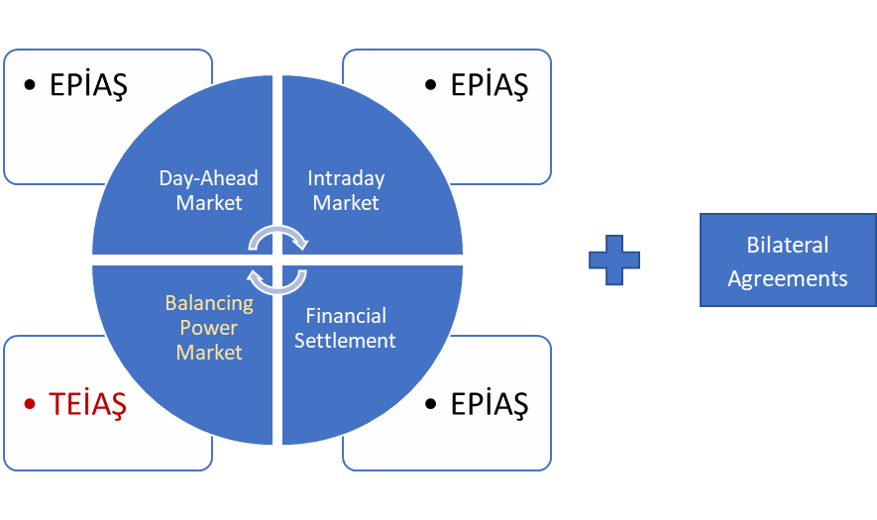

Figure 7: Turkish electricity market

The mechanisms through which the electricity is sold in the wholesale market are Bilateral Contracts (İA), Day-Ahead Market (GÖP), Intraday Market (GİP) and Balancing Power Market (DGP). Each of them is explained in the following sections.

Data about the electricity markets can be easily reached through the transparency platform of EPİAŞ (<https://seffaflik.epias.com.tr>) and through their reports page (<https://rapor.epias.com.tr>)

### Bilateral Contracts (İA)

Bilateral agreements can be submitted to the market system between 00:00-17:00 every day. For a specific day, a bilateral agreement can be submitted at most 60 days earlier and the previous day at the latest. The sides of the agreement have to inform the market operator in order for the balancing to be done properly. The agreeing parties do not have to disclose their price to the market operator. Parties of the agreement can state their conditions and they have to sate all the commercial terms (e.g. method of payment, guaranty…) as well as the time, amount traded and price in the contract.

### Day-Ahead Market (GÖP)

In the day-ahead market, participants place their bids in the current day for the day ahead, hence the name. In this market, each day is split into 24 periods each containing one hour. Each day starts at 00:00 of that day and ends at 00:00 of the next day. Market participants can submit their orders for next day up to 5 days ahead. The daily clearing prices and volumes in the day-ahead market are determined for each hour separately. In this market, a participant does not know the bid or ask prices offered by other participants. The price arising from this market for each hour is called Market Clearing Price (PTF).

#### Process

In the following figure, the process of this market is explained briefly.

Figure 8: Day-Ahead Market process

Day-ahead market participants submit their orders belonging to the next day every day until 12:30 via Market Management System (PYS) to Market Operator.

Collaterals check is performed between 12:30-13:00 in order to determine eligible day-ahead market orders.

Day-ahead market orders submitted to the market operator are verified between 12:30-13:00

Orders that are verified are assessed via optimization tool between 13:00-13:30; market clearing price and market clearing volumes are determined for every hour of the related day.

Commercial transaction approvals containing approved purchase-sale volumes are announced to relevant market participants every day at 13:30. Market participants can object to these notifications in case of errors regarding the transactions between 13:30-13:50

Objections are evaluated between 13:50 -14:00 and relevant results are notified to market participants that made the objection. At 14:00, finalized prices and matched volumes for 24 hours of next day are announced.

Processes mentioned about are daily practices for day-ahead market and “Emergency” and “Additional” processes can be enacted by Market Operator due to technical failures stemming from PYS system. During operation of Emergency and Additional processes, market participants are informed through PYS system.

#### Orders

Different participants can participate in the day-ahead market by submitting different types of orders to the market. These types are single (hourly), block and flexible. Each order consists of quantity-price pairs (QPPs). Each QPP represents either a supply or demand of energy. By convention, supply and demand quantities are given in negative and positive values, respectively. Let *q* denote the quantity and *p* denote the price of a QPP. In any bid, the pair *(p, q)* shows that the participant is willing to pay at most *p* per *MWh* to buy *q* units of electricity or willing to receive at least *p* per *MWh* to sell *q* unit of electricity. The unit of quantity is *“lot”* and *1 lot* equals *0.1 MWh.* Orders (QPPs) can be different for different hours in the same day. Orders can also be modified by the issuer. The different types of orders can be summarized as follows:

Table 1: Types of orders in the day-ahead market

|  |  |  |
| --- | --- | --- |
| Types of orders | | |
| Hourly orders | Block orders | Flexible orders |
| * bidders simply specify a list of QPPs to buy or sell electricity for a single hour of the next day * Prices in an hourly bid must be stated as an increasing sequence * There can be no hourly order exist both in buying and selling direction for the same price level * During the formation of the supply-demand curve, linear interpolation method is employed to interpolate values between two consecutive price/quantity levels | * The second most commonly used type of bids * An indivisible set of consecutive hourly bids, it contains information regarding price, quantity and time periods encompassed * Can encompass a minimum of 3 hours and a maximum of 24 hours * There is only one QPP in a block bid which is constant for all the periods that the block bid spans * A block bid quantity is either totally accepted or totally rejected for all the periods it spans * Block bids can be linked to each other such that the acceptance of a block bid depends on the acceptance of a set of other block bids | * Specify only a price and quantity information (no time information) * Can be accepted at any single hour of the day * Only selling flexible bids can be submitted in the current market system * Either fully accepted or completely rejected * Is accepted if its price is less than or equal to the maximum MCP in the trading day |

A supply block bid is accepted if the bid price is less than or equal to average MCP of the periods spanned by the block bid. Likewise, a demand block bid is accepted if the bid price is greater than or equal to average MCP of the periods the bid spans.

A supply flexible bid is accepted if the bid price is less than or equal to the maximum MCP.

### Intraday Market (GİP)

Intraday Market acts as a bridge between the Day Ahead and the Balancing Markets as it gives participants the opportunity to trade almost in real-time and balance their portfolios in short term.

By means of the Intraday Market, imbalances due to factors such as utility breakdowns and fluctuations of power generation from renewables can be eliminated; participants are allowed to minimize or balance positive/negative imbalances that they might experience during the day. For example, if a wind farm had a large error in their day-ahead wind forecast, the intraday market gives it an opportunity to reduce the imbalances.

Participants can utilize their capacities through Intraday Market trading following the closing time of the day-ahead Market and hereby an additional trading ground is established. Thus, the liquidity of the market is increased. Unlike the day-ahead market, participants can see pending orders in the intraday market for each hour period. In case the new offer matches with an existing order on the order book, exchange price will be equal to the price of the existing order.

The intraday market is a continuous market. Orders can be given until 90 minutes before the physical delivery and can be updated, canceled or rendered inactive. Trading in this market is carried out on an hourly basis. Intraday Market day begins at 00:00 that day and ends at 00:00 the following day. Intraday market orders that are made for the following day can only be given after 18:00 which is also the intraday market opening time.

Unlike the single session tender of the day-ahead market, intraday market orders are processed instantaneously and matched with orders in the opposite direction.

#### Orders

Participants may place their orders in hourly and/or block orders for a particular time period within the scope of the Intraday Market. Orders comprise quantity and price information which may vary for different hour periods.

Table 2: Types of orders in the intraday market

|  |  |
| --- | --- |
| Types of orders | |
| Hourly orders | Block orders |
| * Divisible orders i.e. they can be matched partially or completely | * Not divisible therefore they can only be matched as a whole * A block order contains a minimum of 1 and a maximum of 24 hour(s) * A block order cannot include hours from 2 different days |

### Balancing Power Market (DGP)

This market is the last line of defense to ensure that the generation balances the consumption of electricity. Only generation facilities can participate in this market. Facilities which can independently inject or offtake at least 10 MWh in less than 15 minutes are obliged to participate in the balancing power market. All the market participants should make their capacity at disposal for any orders. DGP market processes take place daily on an hourly basis, i.e. the prices are calculated for each hour separately. The price arising from this market for each hour is called System Marginal Price (SMF).

Because deviations from the forecasted electricity generation and consumption amounts always happen in real time, the system operator (MYTM) uses the offers presented in this market to balance the system.

The main purpose of this market is balancing the system in real time, not trading electricity. Trading in this market is quite risky, hence the day-ahead and intraday markets are more suitable for it.

Because the electric energy should be consumed whenever it is generated, the value of Area Control Error (ACE) should be kept at zero or close to zero.

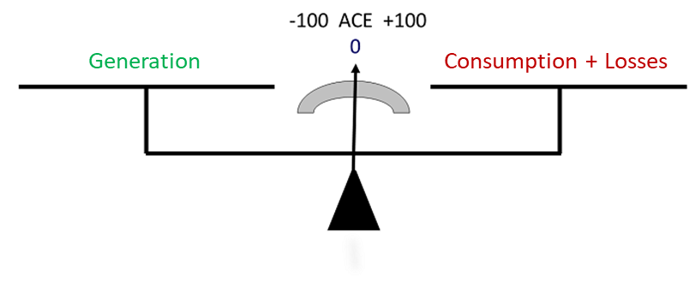

Figure 9: System balance

According to the electricity market network regulations, the network frequency is 50 Hz.

If the frequency is less than 50, this means that generation is less than consumption. To fix this problem, the generation has to increase, or the consumption has to decrease.

If the frequency is greater than 50, this means that generation is greater than consumption. To fix this problem, the generation has to decrease.

#### Process

The market starts operation after the day-ahead market finished, at 14:00.

Market participants have to inform the system operator about:

* Their hourly generation schedules for the next day
* Their offers for electricity injection and offtake

Through the Market Management System (PYS) between 14:00 - 16:00.

The injection and offtake offers are then ordered by the market operator according to their price.

Starting from 17:00 the system operator sends instructions to different participants whenever necessary to eliminate any imbalances.

#### Offers

* Market participants can offer 15 price levels for each of the injection and offtake directions
* Injection offer prices must be larger than the market clearing price for the same hour period
* Offtake offer prices must be less than the market clearing price for the same hour period
* The change in price level between first and last price levels cannot exceed 20% except for hydroelectric power stations
* For injection, the price levels have to be listed in an increasing order
* For offtake, the price levels have to be listed in a decreasing order
* For both injection and offtake, the minimum volume is 10 MWh



Injection

Offtake

Figure 10: Example offer

If a generation plant couldn’t generate electricity according to the instructions it received from the system operator, it has to submit his excuse to the market management system within 4 hours.

#### System Marginal Price

The price for each hour is calculated as follows:

Taking into account all the instructions given in the market, the net instruction direction and volume is calculated. If the direction is deficit, the injection offers are considered, starting from the least price. The price at which the cumulative offer amounts equal the deficit amount becomes the system marginal price.

On the other hand, if the direction is surplus, the offtake offers are considered, starting from the highest price. The price at which the cumulative offer amounts equal the surplus amount becomes the system marginal price.

The transactions with all the generation facilities are performed at this price level.

### Financial Settlement

The financial settlement of İA, GÖP and GİP market transactions is made monthly after reading the meters. It happens 15 days after the end of each month and is paid along with the monthly bill.

# References

* EPİAŞ website (Market operations webpages)  
  <https://www.epias.com.tr/en>
* EPİAŞ annual report 2017  
  <https://www.epias.com.tr/wp-content/uploads/2018/06/EPIAS_Annual_Report_2017.pdf>
* EPİAŞ electricity market report 2017  
  <https://www.epias.com.tr/wp-content/uploads/2018/05/EP%C4%B0AS_2017_Y%C4%B1ll%C4%B1k_B%C3%BClten_eng.pdf>
* EPDK electricity market development report 2017  
  <https://www.epdk.org.tr/Detay/DownloadDocument?id=baMXxaZ/ZLs>
* TEİAŞ Turkish electricity market webpage  
  <https://www.teias.gov.tr/tr/yayinlar-raporlar/piyasa-raporlari>
* News about TETAŞ and EÜAŞ merger  
  <http://ekonomi.haber7.com/ekonomi/haber/2665713-tetas-ve-euas-euas-bunyesinde-birlestirildi>
* Practical Law™ electricity regulation in turkey: overview  
  <https://uk.practicallaw.thomsonreuters.com/0-523-5654>
* CIA world factbook electricity consumption by country  
  <https://www.cia.gov/library/publications/the-world-factbook/rankorder/2233rank.html>
* PwC Turkish Electricity Market Fundamental Information and Current Structure Study
* PwC publications about the Turkish electricity market (the link does not contain the study above)  
  <https://www.pwc.com.tr/en/sektorler/enerji-altyapi-madencilik/elektrik-altyapi.html>

# About the Author

Mohammed Saif is an industrial engineer who has a passion for data science. Currently working on electricity load forecasting in the Turkish market using machine learning algorithms in [Algopoly R&D](https://algopoly.com/), Istanbul. He studied for his industrial engineering degree at the Middle East Technical University, Ankara, Turkey.

To contact Mohammed, you can send an email to [m.saif.ka@gmail.com](mailto:m.saif.ka@gmail.com)

Or through LinkedIn: [www.linkedin.com/in/MoSaifK](http://www.linkedin.com/in/MoSaifK)